**Aim: Create a simple cloud software application for online super market using any Cloud Service Provider to demonstrate SaaS with the template of customer name, address, phone, email, items, quantity etc. with the item classification form.**

**Step 1:** create an application ‘online super market’, add a form ‘grocery’ and add details.

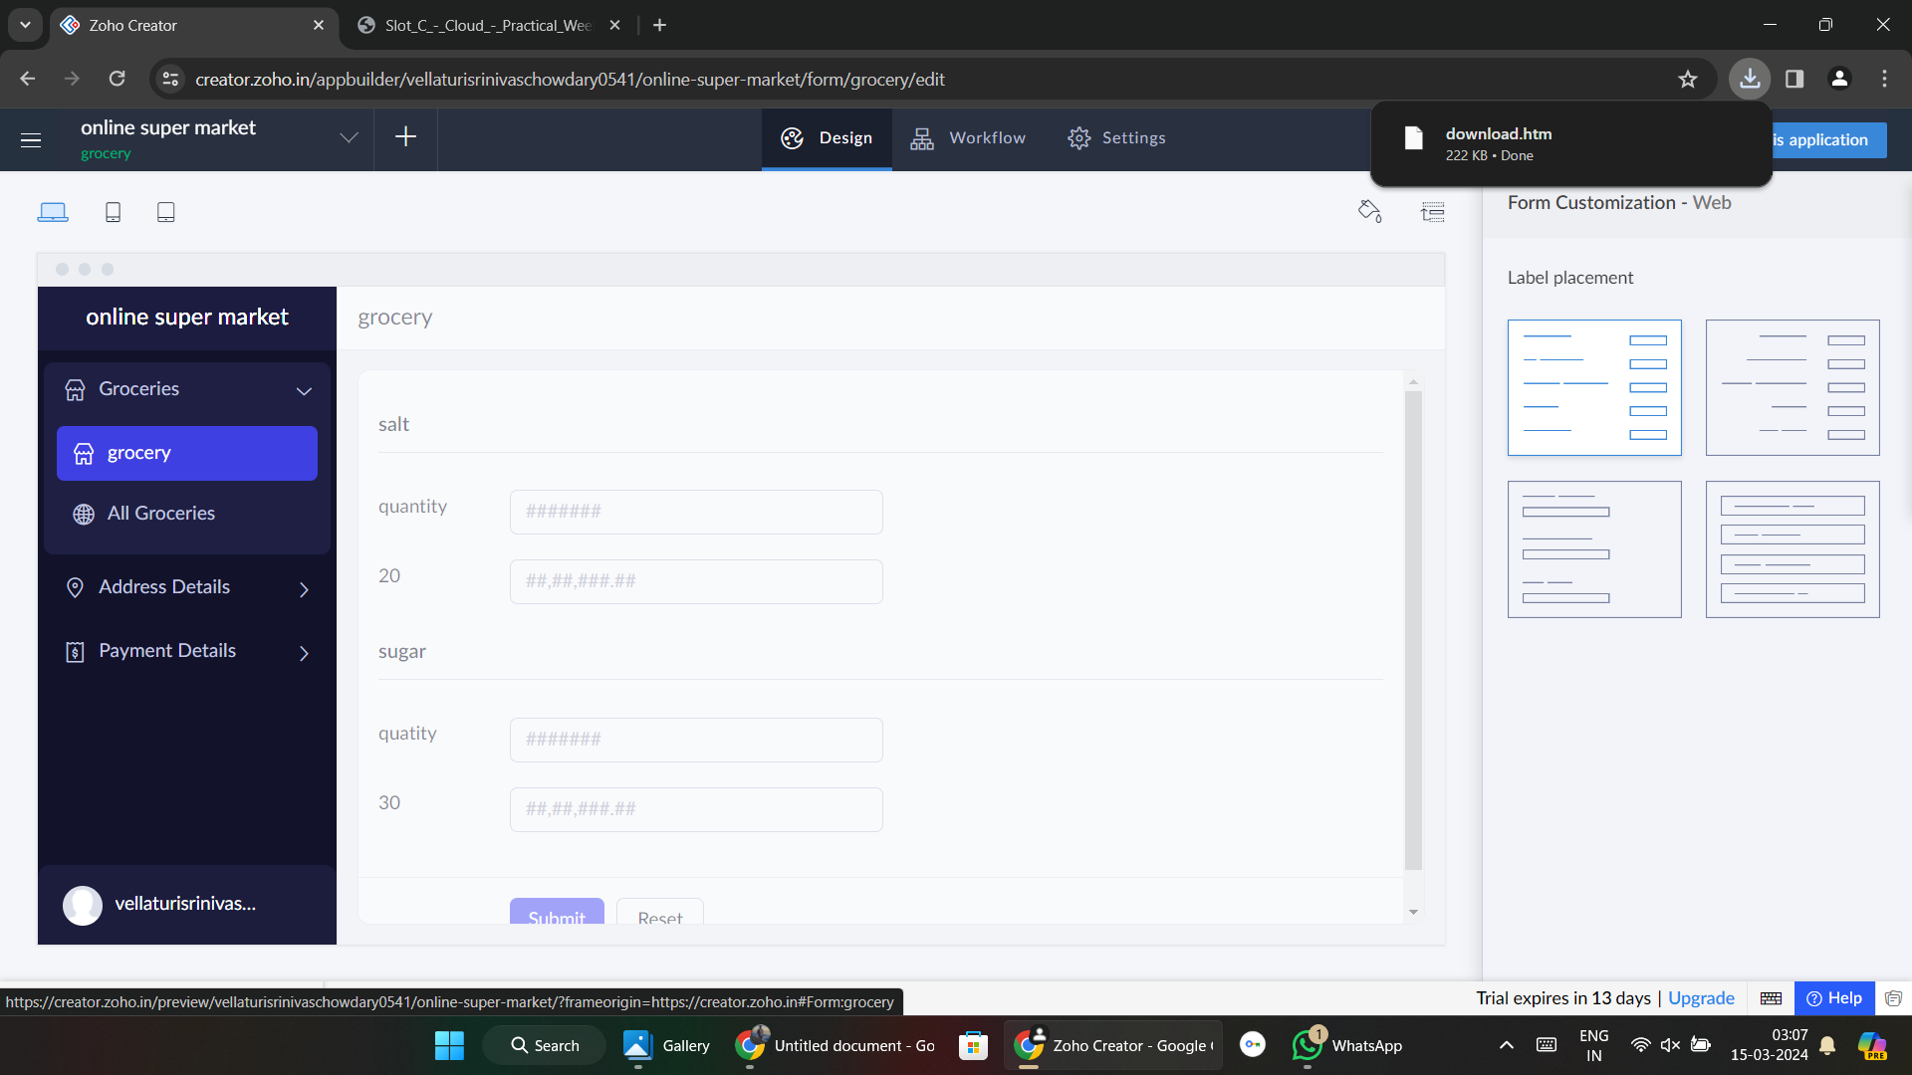

**Step 2:** create a form ‘address details’ and add details.

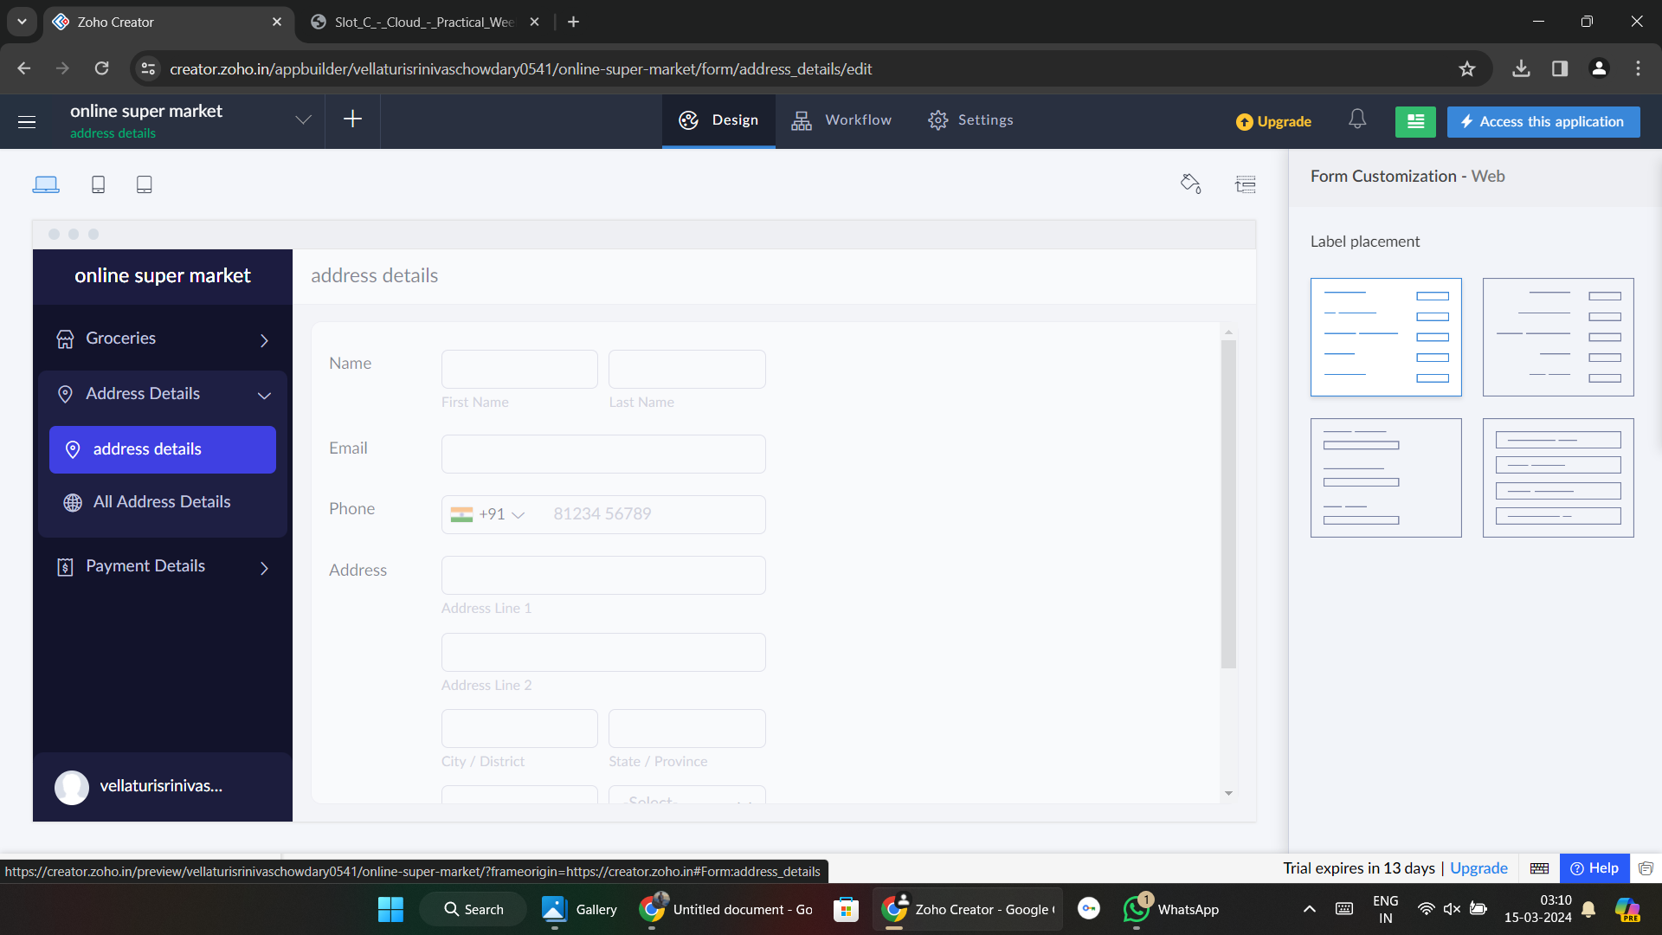

**Step 3:** add a form ‘payment details’ and add details.

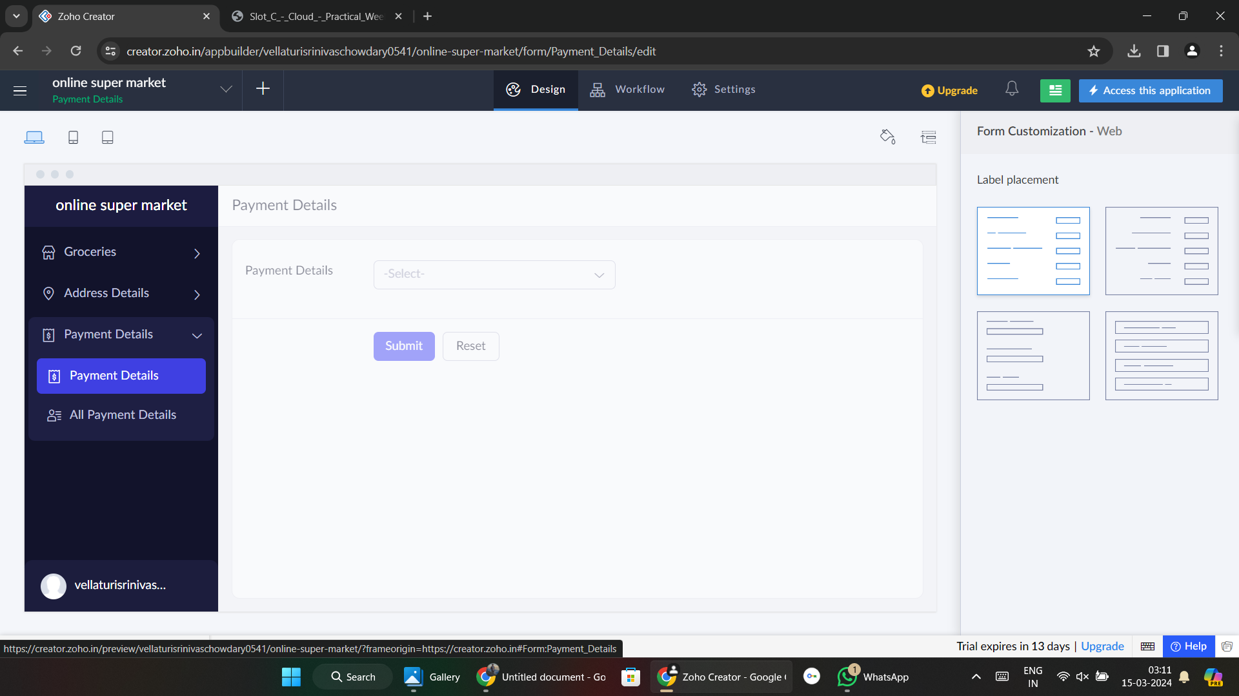

**Step 4:** add details